**TO:** [**santyclaus@magicland.northpole.yes**](mailto:santyclaus@magicland.northpole.yes)

**FROM:** [**nastia@gmail.com**](mailto:nastia@gmail.com)

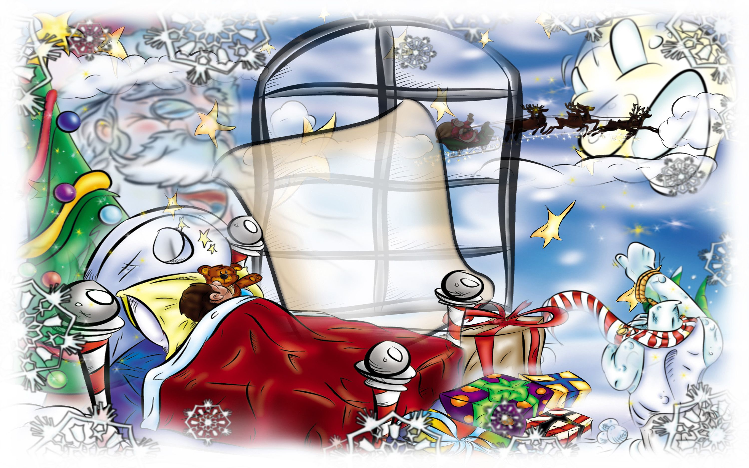 **Dear St Nicholas!**

**Thank you for your presents last year! I was a good girl this year too. My Dad said I have to tell you how good I am.**

**I help my Mom. I read. I go dancing. I brush my teeth every day. I even make my bed. Could you give me a present? I want a puppy. It is white with black nose and small ears. It is playful and funny. I will take care of it, I promise!**

**Thank you!**



Dear St Nicholas!

How are you?

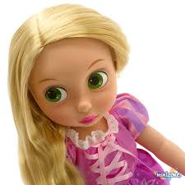I am Olena. I am 10 years old. I do well at school. I help my Mom and Dad. I like travelling and I have a collection of dolls. They are from Turkey, Poland, China, Germany. I have a dream. I want a doll from Australia. It has got long fair hair and pretty green hat. Green is my favourite colour.

Please?.. Thank you!

